ASSIGNMENT 8
Name: SHASHWATH S SHETTY
Class: 3C
USN: ENG25CY3003

11. What is a user-defined function in shell scripting? Explain with an example.
Soln:
A user-defined function in shell scripting is a block of code assigned a name, designed to perform a specific task or set of tasks. Functions promote code reusability, improve script readability, and help organize complex scripts into modular components.
Ex:
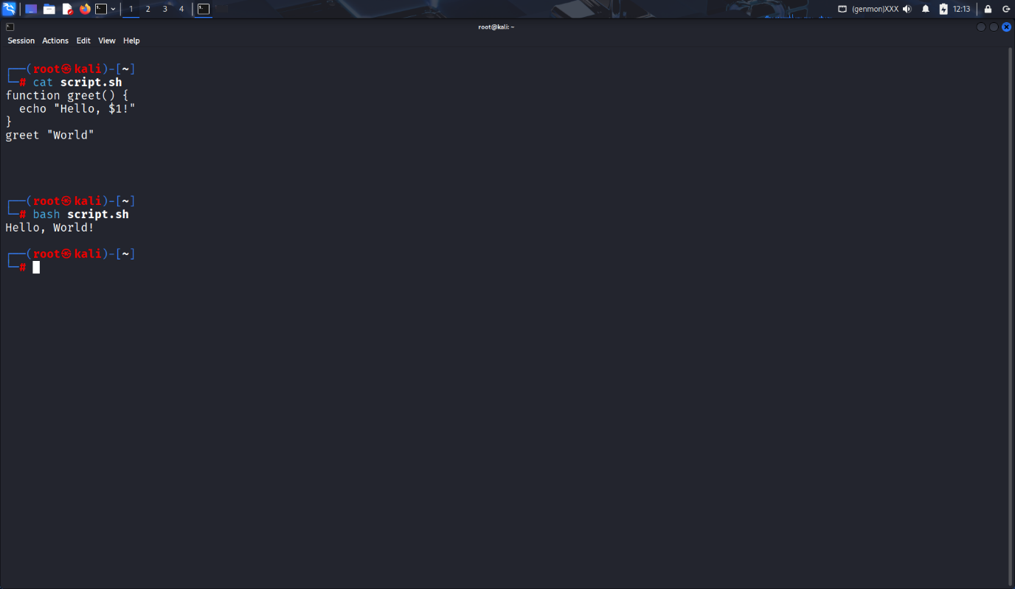

12. Write a bash script with a function that multiply two integer numbers.
Soln:
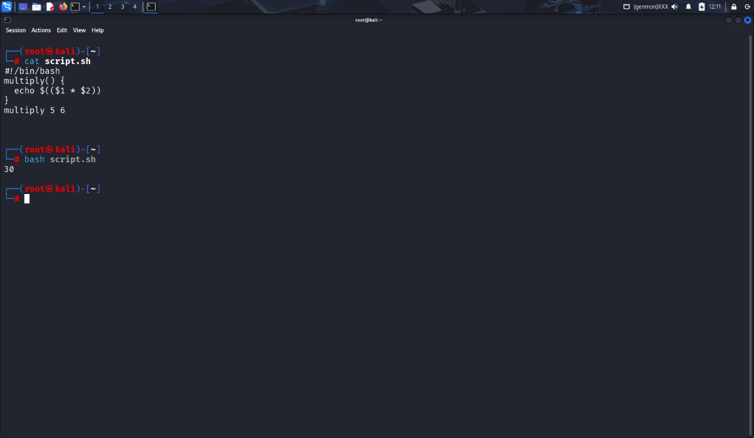

13. Explain how arrays (1D, 2D, and 3D) are declared in bash scripting.
Soln:
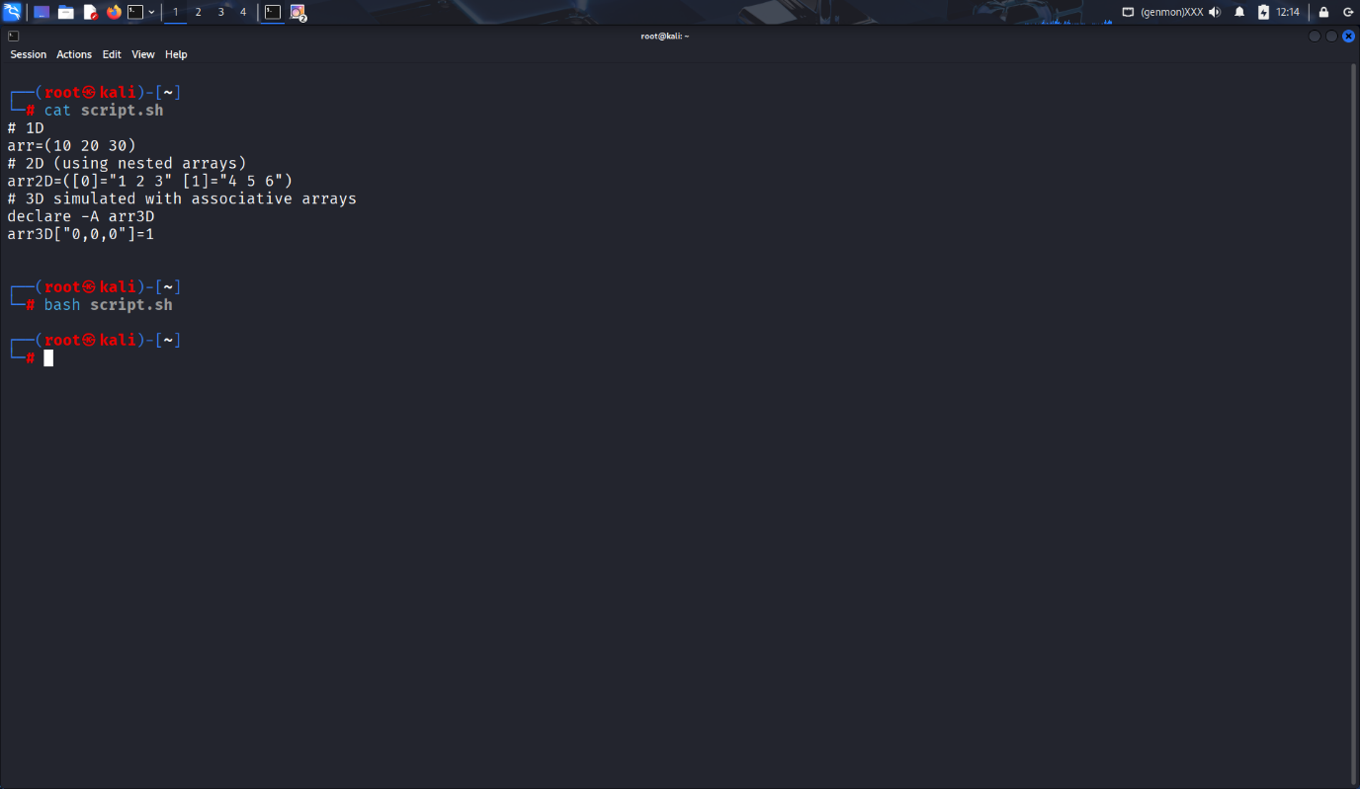

14. Write a shell script to display elements of an array.
Soln:
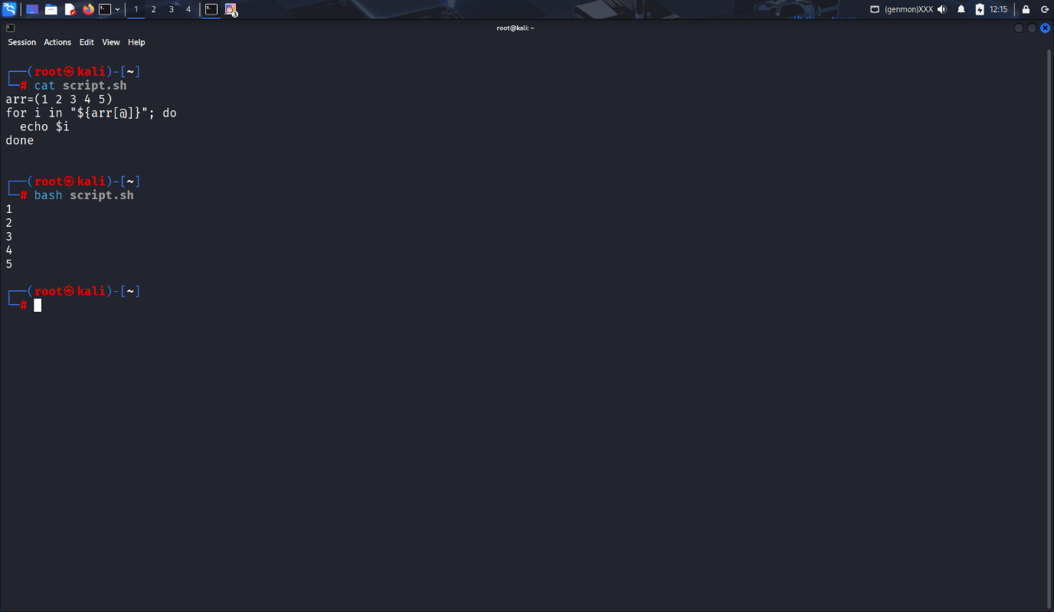

15. What is the purpose of cron in Linux?
Soln:
The purpose of cron in Linux is to schedule and automate repetitive tasks at specific times or intervals. It is managed by a background service called the cron daemon (crond), which reads configuration files called crontabs to know when and what to execute. This automation is essential for system administration and various operational tasks.

16. Write a cron job to run a backup script every day at midnight.
Soln:
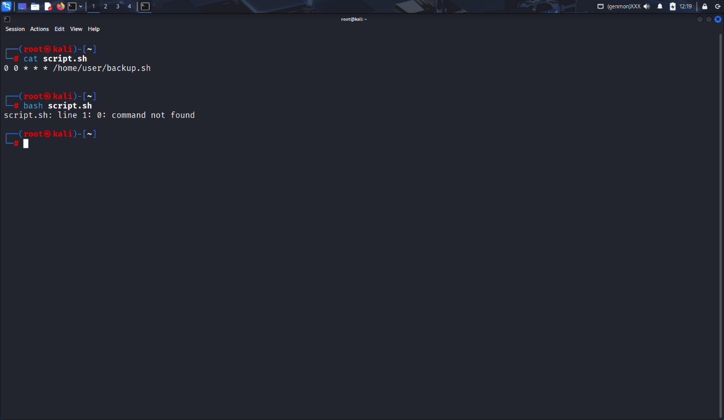

17. How do you schedule a one-time job using at command?
Soln:
at 10:00 PM

18. Write a script to display disk usage using df and du.
Soln:
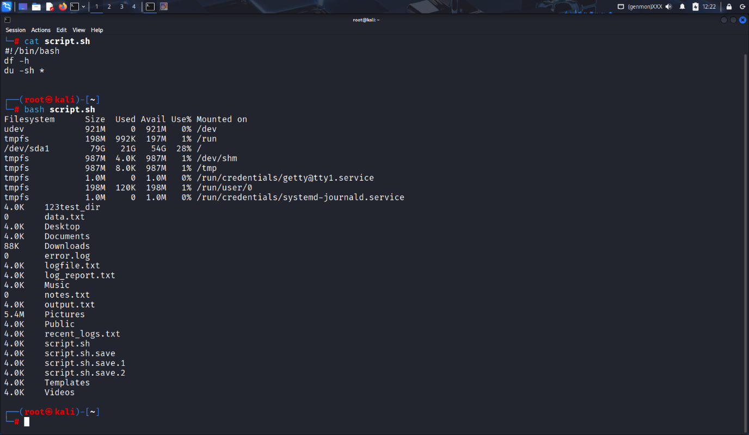

19. How can you log the output of a script using the tee command?
Soln:
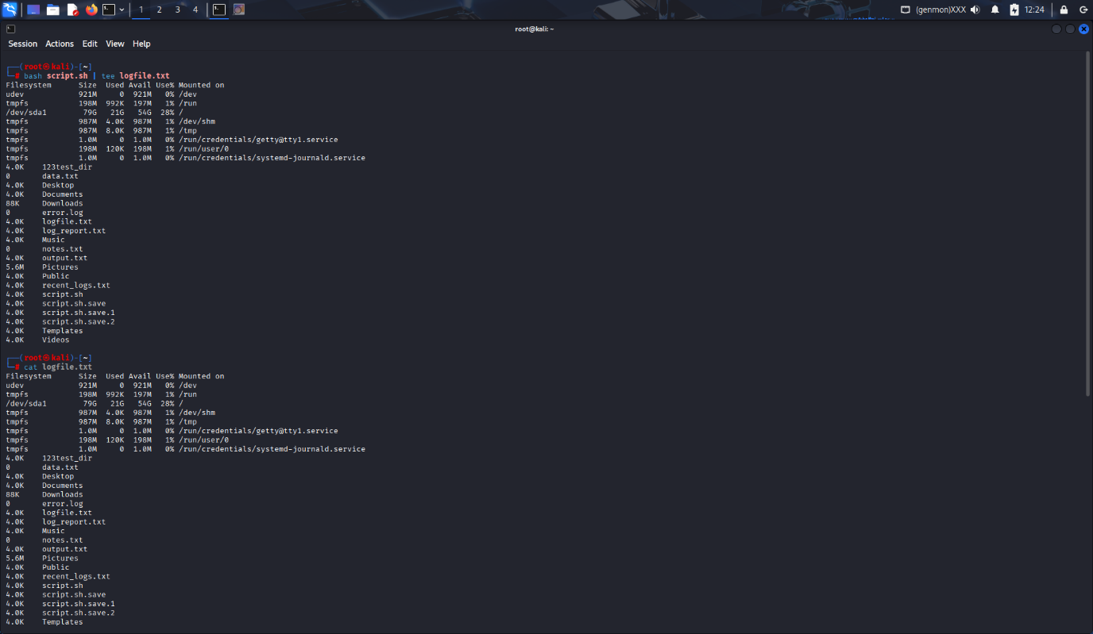

20. Explain with an example how shell scripting can automate system administration tasks.
Soln:
